Directions: The goal of the following problems is to help challenge and deepen your understanding of the current topic. Don’t assume that you will know how to answer every question. You will work with at least two other students in the class to try and find solutions and write arguments for each of the following questions. Be sure that you question your classmates’ reasoning. If you don’t understand how they are getting something, you should ASK THEM TO EXPLAIN! Being able to defend your reasoning is important and so you are actually helping them by asking them to explain.

Challenge Questions

- Consider the curve , . Eliminate the parameter to find a Cartesian equation of the curve. Then sketch the curve and indicate the orientation of the curve.

Note that . Therefore, .
So, this is the graph of shifted up 3 units.
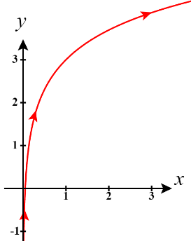

- Let C be the portion of curve of from to .
- Create two different parameterizations for C.

Let and where .
Also and where .

- Create a parameterization for (this is the same as the curve C but traced in the opposite direction).

Let and where .
Note that reverses the inputs for values of t.

- Consider the curve , .
- Make a sketch of the curve for by plotting points. Don’t use your calculator.

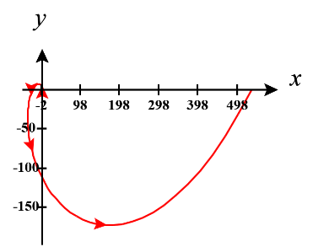
t | x | y
0 | 1 | 0
 | 0 | 1
 |  | 0
 | 0
 |  | 0

- Determine when the tangent line to this equation is horizontal and when it is vertical.

Note .
Therefore, and where k is some integer.

This implies that when there are vertical tangent lines and when there are horizontal tangent lines.

- Find the arc length for this path for t from 0 to 1.

We already calculated and in part (b) and see that these functions are continuous and since is always increasing and never repeat coordinates. Therefore, the length of the curve is

- Consider the curve , .

- Determine at what value(s) of t the curve reaches the point .
In order to arrive at the point we need to find a value of t that makes the x formula output 1 and the y formula output 0.

We see that
Also .
Therefore, the point is reached when and when .

- Find all values of t for which the tangent line is horizontal or is vertical.

Note .
Therefore, and .
This implies that when (at the point ) there is a vertical tangent line and when (at the points and ) there are horizontal tangent lines.

- Use and together with intercepts and behavior as to sketch the curve. Don’t use your calculator.
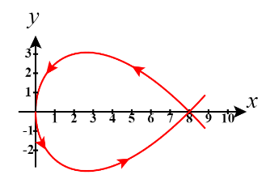
Note that and
So we see that the point is on the graph when . Also when we have the point .

We also note that as we have and .

- Find the slope of the two tangent lines at .
From part (a) we know that .
From part (b) we know that the point is reached when .

Therefore, the slope of the two tangent lines at this point are and
- Consider the curve , .
- Show that this curve models a particle traveling counterclockwise about an ellipse starting at the point . Recall that the general form for the equation of an ellipse centered at the origin is .
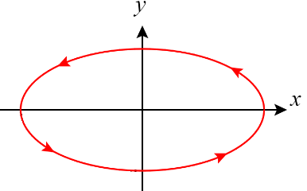
Note that and we know this is the equation of an ellipse. When we are at the point and at the point .

- Determine for what t the tangent line has slope .

We calculate .
Therefore .

- Setup, but do not evaluate, the integral for the circumference of the ellipse using this set of parametric equations. This integral is an “elliptical” integral and is another integral that does not have a nice anti-derivative.

Note that on the interval , are continuous and the curve is not retraced.
Therefore, .

- The parameterization , for creates a unit circle with counterclockwise orientation.

- Create a parameterization for a unit circle with clockwise orientation.

Let , for

- Create a parameterization for a circle of radius r.

Let , for
OR
Let , for

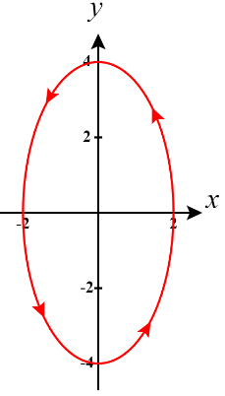
- Create a parameterization for the following ellipse.

Let where .

